[TC-MR12-23] Generate Distribution Lists – Generate Full Lists
Result: FAIL
Reason: The ADDITIONAL DISTRIBUTION LIST ( Andrei Popovici-MARS) is not produced.
1) Overall distribution lists (also an ADDITIONAL DISTRIBUTION LIST is selected)
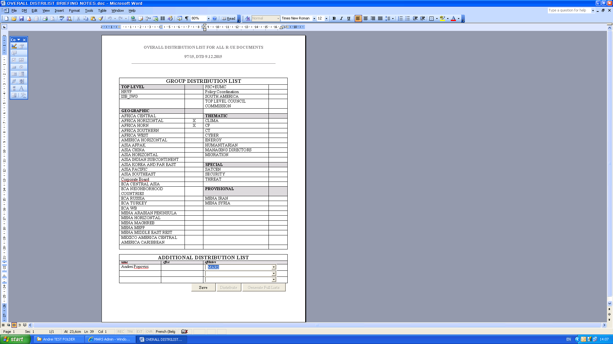

Expected result: ( from R3-TFS M11)
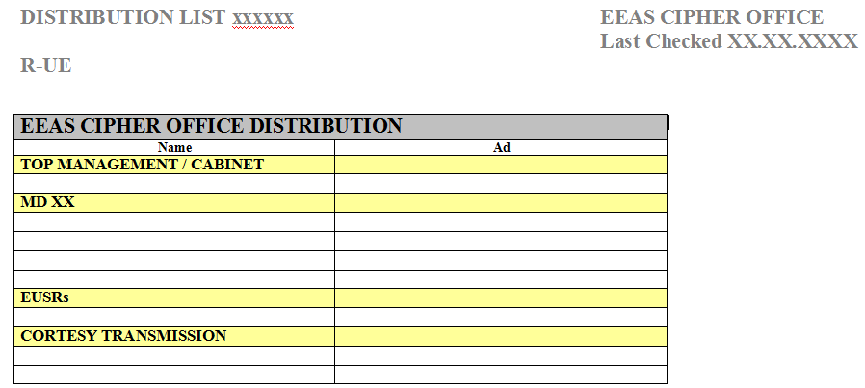
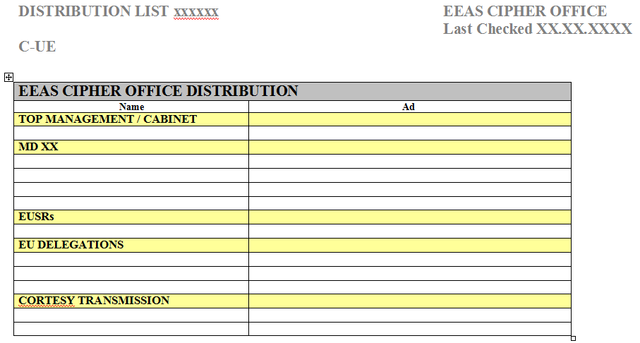
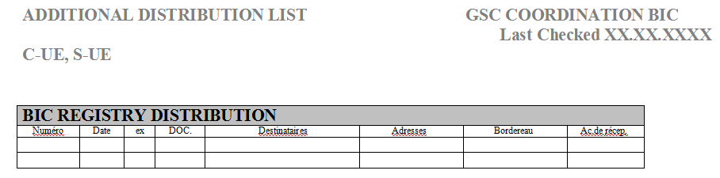

Actual result: The ADDITIONAL DISTRIBUTION LIST ( Andrei Popovici-MARS) is not created (see below)
